**TRANSFER OF APPOINTMENT BOOKLET**

**23rd May 2025**

**CV of Lieutenant General Seán Clancy**

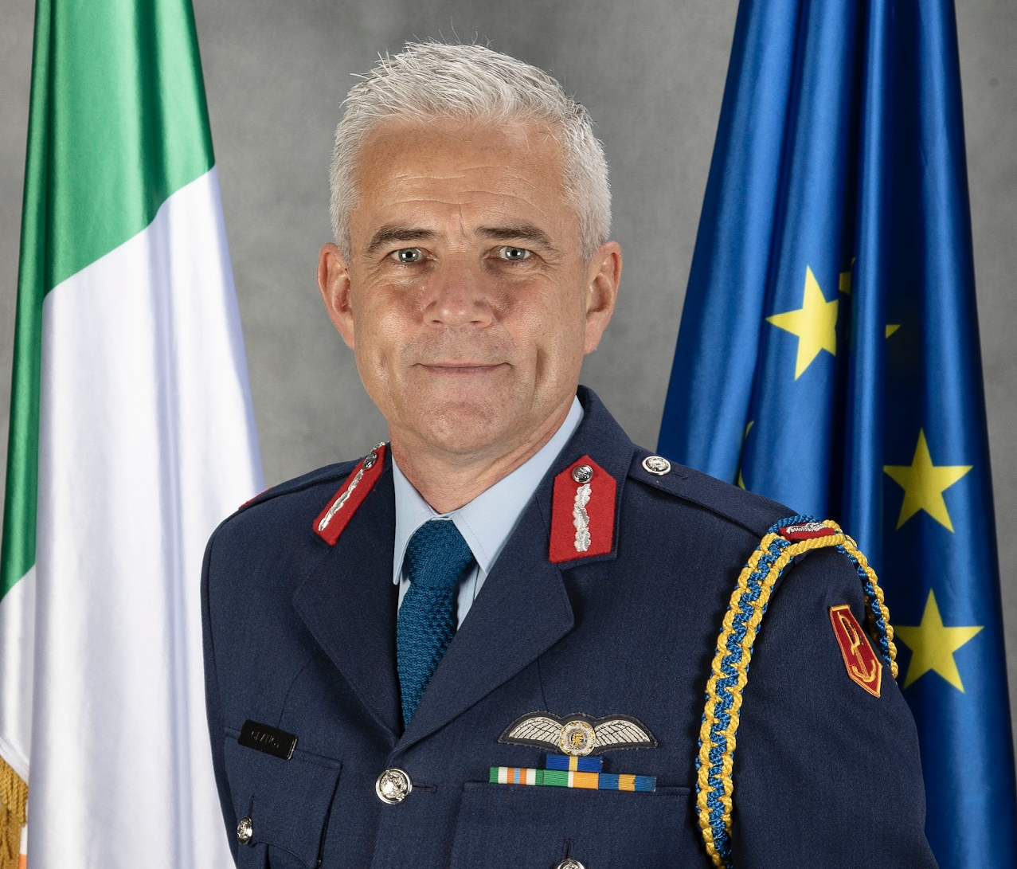Lt General Seán Clancy has 39 years’ service in the Irish Defence Forces. He is the first Air Chief in the Irish State to serve as Chief of Staff (CHOD), a position he has held since 2021 having previously served as Deputy Chief of Staff (Support) and as General Officer Commanding the Air Corps.

Lt General Clancy is the principal military advisor to the Minister of Defence and the Irish Government and serves on key strategic boards at the State policy level. He has been clear and decisive communicator, a driver of change and an innovation champion throughout his career in the Defence Forces. As CHOD, he contributed to the Commission on the Future of the Defence Forces and following Government approval of that Report’s recommendations, he is now leading a significant and generational transformation and cultural change programme.

As Deputy CHOD he played a central role in the development of the Defence Forces Research and Technology Unit and previously led the establishment of Ireland’s first Emergency Aeromedical Service. He has been a strong advocate for Leadership and was the co-author of the Defence Forces Leadership Doctrine published in 2016.

As CHOD, he has advocated for and overseen the expansion of the Defence Forces levels of engagement in PESCO projects, has advanced interoperability levels through procurement of tri-Service capabilities including, inter alia, the ESSOR system, and is currently overseeing the preparations of the Irish Defence Forces for EUBG participation in 2025. Lt General Clancy has prioritised the standardisation and interoperability of the Defence Forces to enable partnership operational success and has led on the adoption of European capability development practices into national structures.

Lt General Clancy has served with the European Union Force in Bosnia as the Military Advisor to the Force Commander and spent two years as air advisor to the permanent element of SHIRBRIG, the UN Standby Brigade. As Chair of the NATO PIAG (2022 – 2024) he focused on strengthening the partnership concept to further enable European defence and resilience.

Lt General Clancy joined the Irish Defence Forces in 1984, has flown both fixed and rotary wing aircraft and is a qualified helicopter instructor and examiner. During his career he has served in appointments including Squadron Commander, Wing Commander, Senior Staff Officer Operations, Senior Staff Officer Personnel, Chief of Air Staff Support, Director of Strategic Planning Branch at Defence Headquarters and Head of Service as General Officer Commanding, Irish Air Corps and Director of Military Aviation.

Lt General Clancy spent much of his early career as a Search and Rescue pilot and was the Commander of the crew who received the State Marine Medal for Meritorious Service in 2002. He holds a Bachelor of Science Degree from Trinity College, Dublin, a Masters in Military Leadership and Defence Studies from the National University of Ireland, Maynooth and completed a Higher Level Diploma in Advanced Management Performance at UCD Smurfit Business School. He is a graduate of the Defence Forces Command and Staff College where he was the recipient of the Lt General Tadgh O’Neill valedictorian award.

Lt General Clancy is married to Caroline. They have three children and live in Dublin.

**CV Brigadier General Rossa Mulcahy**

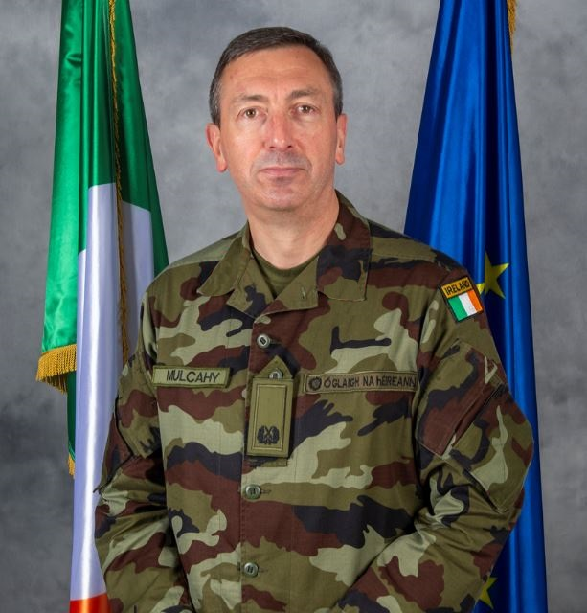Brigadier General Rossa Mulcahy is a professional communications officer with over 39 years' experience in a variety of roles across the Defence Forces as well as deployments with the United Nations and NATO.

Rossa took up his appointment as Assistant Chief of Staff in Oct 2021 and has responsibility for a range of organisational level issues including; Organisation Transformation, Capability Development, Innovation, Risk Management, Corporate Governance, and Industrial Relations, Doctrine and Cultural Transformation.

Brigadier General Mulcahy has previously served as Director of Strategic Planning Branch from Feb 2020, where he was responsible for Strategy Development, Defence Policy Programme Implementation, Defence Forces' Annual Plans, and International Security and Defence Policy coordination. From 2019 he was the Director of Communications and Information Services, with cyber being one of his areas of responsibility. Brigadier General Mulcahy has served in all of the CIS Units within the Army; he has held appointments in the Joint Command and Staff School and the Defence Forces' Management Information Framework Section as a Lieutenant Colonel.

Rossa's educational qualifications include a B. COMM from NUIG, a Higher Diploma in Information Technology from NUIM, a B.Sc. in Management Information Systems from UCD, an MA in Leadership Management and Defence Studies from NUIM and most recently a Professional Diploma in Strategy Development and Innovation from the Smurfit Business School, UCD. He is a graduate of the Defence Forces' Senior Command & Staff Course (2008) and the US Army Command and General Staff College (2011). His overseas experience includes:

* Three (3) deployments to Lebanon with UNIFIL
* Two (2) years on deployment to Syria and Lebanon with UNTSO
* Deployment as Irish National Senior and Deputy KLE Branch at NATO's Resolute Support mission, in Kabul, Afghanistan.

Rossa is married to Lorna and they have two daughters, Caoimhe and Laoise. He will be promoted to the rank of Lieutenant General upon taking up the appointment of Chief of Staff.

**Commanders in Chief and Chiefs of Staff of the Army and the Defence Forces**

|  |  |
| --- | --- |
| NAME | FROM/TO |
| General Eoin O Duffy | Feb 1922 to Jul 1922 |
| General Richard Mulcahy | Jul 1922 to Aug 1922 |
| General Sean McMahon | Aug 1922 to Mar 1924 |
| General Peadar McMahon | Mar 1924 to Mar 1927 |
| General Daniel Hogan | Mar 1927 to Feb 1929 |
| General Sean McKeon | Feb 1929 to Oct 1929 |
| Lieutenant General Joseph Sweeney | Oct 1929 to Oct 1931 |
| Lieutenant General Michael Brennan | Oct 1931 to Jan 1940 |
| General Daniel McKenna | Jan 1940 to Jan 1949 |
| Lieutenant General Liam Archer | Jan 1949 to Jan 1952 |
| Major General Liam Egan | Jan 1952 to Dec 1954 |
| Lieutenant General Patrick A. Mulcahy | Jan 1955 to Dec 1959 |
| Lieutenant General Sean McKeown DSM | Jan 1960 to Dec 1960 & Apr 1962 to Mar 1971 |
| Lieutenant General Sean Collins-Powell | Jan 1961 to Mar 1962 |
| Major General Patrick Delaney | Apr 1971 to July 1971 |
| Major General Thomas L. O’Carroll | July 1971 to July 1976 |
| Lieutenant General Carl O’Sullivan DSM | July 1976 to June 1981 |
| Lieutenant General Louis Hogan DSM | June 1981 to April 1984 |
| Lieutenant General Gerald O’Sullivan DSM | April 1984 to Feb 1986 |
| Lieutenant General Tadhg O’Neill DSM | Feb 1986 to Oct 1989 |
| Lieutenant General James Parker DSM | Oct 1989 to April 1992 |
| Lieutenant General Noel Bergin DSM | Apr 1992 to Dec 1994 |
| Lieutenant General Gerard McMahon DSM | Feb 1995 to Aug 1998 |
| Lieutenant General David Stapleton DSM | Aug 1998 to Sept 2000 |
| Lieutenant General Colm Mangan DSM | Sept 2000 to Feb 2004 |
| Lieutenant General James Sreenan DSM | Feb 2004 to June 2007 |
| Lieutenant General Dermot Earley DSM | June 2007 to June 2010 |
| Lieutenant General Seam McCann DSM | June 2010 to Aug 2013 |
| Lieutenant General Conor O Boyle DSM | Aug 2014 to Sept 2015 |
| Vice Admiral Mark Mellett DSM | Sept 2015 to Sept 2021 |
| Lieutenant General Seán Clancy | Sept 2021 to May 2025 |
| Lieutenant General Rossa Mulcahy | May 2025 to |